# AAE6102 Assignment 1

## Satellite Communication and Navigation (2024/25 Semester 2)

### Task 1 – Acquisition

Process the IF data using a GNSS SDR and generate the initial acquisition results.

The result file is in Task1.

Tab. 1. Initial acquisition results of Open-Sky dataset

|  |  |  |  |  |  |  |  |  |
| --- | --- | --- | --- | --- | --- | --- | --- | --- |
| SV | 3 | 4 | 16 | 22 | 26 | 27 | 31 | 32 |
| SNR | 18.0953 | 17.2936 | 26.4349 | 19.8321 | 27.2060 | 22.7206 | 24.4017 | 22.1983 |
| Doppler | 1000 | -3000 | 0 | 1500 | 2000 | -3000 | 1000 | 3500 |
| CodeDelay | 3683 | 12701 | 26051 | 2610 | 57908 | 49778 | 39064 | 20170 |
| FineFreq | 4580990 | 4576905 | 4579695 | 4581565 | 4581835 | 4576775 | 4581045 | 4583345 |

Description: Open-Sky: SV (Satellite IDs): A list of satellite identification numbers: [3, 4, 16, 22, 26, 27, 31, 32]. SNR (Signal-to-Noise Ratio): A list of signal-to-noise ratios corresponding to each satellite: [18.0953, 17.2936, 26.4349, 18.8321, 27.2060, 22.7266, 24.4017, 22.1983]. Doppler: The Doppler frequency shifts for the corresponding satellites: [1000, -3000, 0, 1500, 2000, -3000, 1000, 3500]. CodeDelay: The code delays for each satellite: [3683, 12701, 26051, 2610, 57098, 49778, 30964, 20170]. FineFreq: The fine frequency adjustment values for the corresponding satellites: [4580909, 4576905, 4579695, 4561565, 4581835, 4576775, 4581045, 4583345].

Tab. 2. Initial acquisition results of Urban dataset

|  |  |  |  |  |  |
| --- | --- | --- | --- | --- | --- |
| SV | 1 | 3 | 7 | 11 | 22 |
| SNR | 42.6344 | 29.3771 | 19.9028 | 23.0521 | 17.7927 |
| Doppler | 1000 | 4500 | 500 | 500 | 3500 |
| CodeDelay | 22742 | 1154 | 10811 | 24851 | 2050 |
| FineFreq | 1200 | 4285 | 365 | 405 | 3315 |

Description: Open-Sky: SV (Satellite IDs): A list of satellite identification numbers: [1, 3, 7, 11, 22]. SNR (Signal-to-Noise Ratio): A list of signal-to-noise ratios corresponding to each satellite: [42.6344, 29.3771, 19.9028, 23.0521, 17.7927]. Doppler: The Doppler frequency shifts for the corresponding satellites: [1000, 4500, 500, 500, 3500]. CodeDelay: The code delays for each satellite: [22742, 1154, 10811, 24851, 2050]. FineFreq: The fine frequency adjustment values for the corresponding satellites: [1200, 4285, 365, 405, 3315].

### Task 2 – Tracking

Adapt the tracking loop (DLL) to generate correlation plots and analyze the tracking performance. Discuss the impact of urban interference on the correlation peaks. (Multiple correlators must be implemented for plotting the correlation function.)

The result file is in Task2.

Discussion on Urban Interference:

Multipath Effects:

In urban environments, signals can bounce off buildings and other structures, causing multipath interference. This results in multiple signal paths arriving at different times, which can lead to smearing of correlation peaks.

Tracking Difficulties:

Under significant urban interference, the DLL may have difficulty locking onto the signal due to competing signals, leading to a lower correlation peak and wider spread.

Mitigation Strategies:

Adaptive Algorithms: Consider using adaptive filtering techniques to improve performance in multipath environments.

Signal Processing Enhancements: Incorporate additional techniques like signal averaging or combining measurements from multiple satellites to improve robustness against interference.

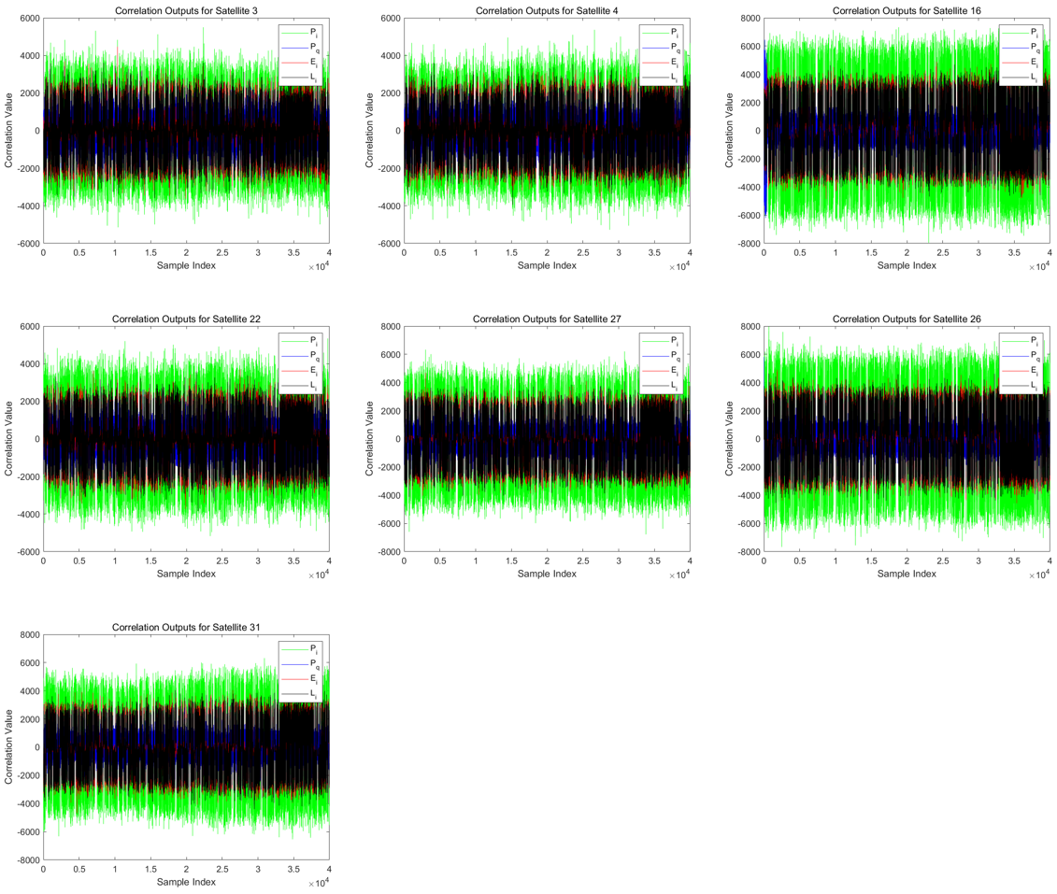

Fig. 1. The correlation plots of Open-Sky dataset

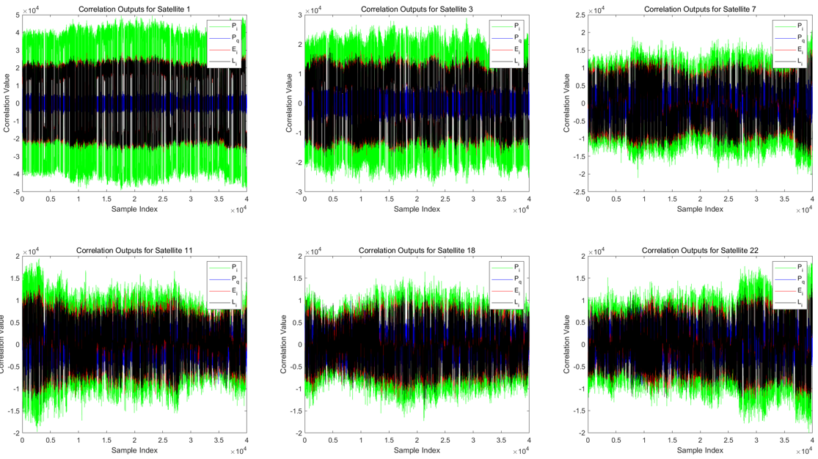

Fig. 2. The correlation plots of Urban dataset

### Task 3 – Navigation Data Decoding

Decode the navigation message and extract key parameters, such as ephemeris data, for at least one satellite.

The result file is in Task3.

eph (Ephemeris):

Represents the satellite's ephemeris data.

Contains orbital information about the satellite, allowing the receiver to calculate the satellite's precise position at any given time.

Ephemeris data is crucial for accurate positioning as it helps adjust the received signal delays.

sbf (Subframe):

Represents subframe data from the navigation message.

Contains information about the satellite's status, health, timing, and other navigation-related details.

Decoding the subframe helps the receiver understand the timing information of the signal and provides necessary data for position calculations.

TckResult_Eph (Tracking Result Ephemeris):

Stores the results obtained from conventional tracking processes.

Contains information related to signal tracking, such as signal strength, frequency offset, code phase, etc.

These tracking results are used for further navigation data processing and position calculations.

(The result file is larger than 25 MB and therefore not uploaded.)

### Task 4 – Position and Velocity Estimation

Using pseudorange measurements from tracking, implement the Weighted Least Squares (WLS) algorithm to compute the user's position and velocity.

The result file is in Task4.

Plot the user position and velocity.

Compare the results with the ground truth.

Discuss the impact of multipath effects on the WLS solution.

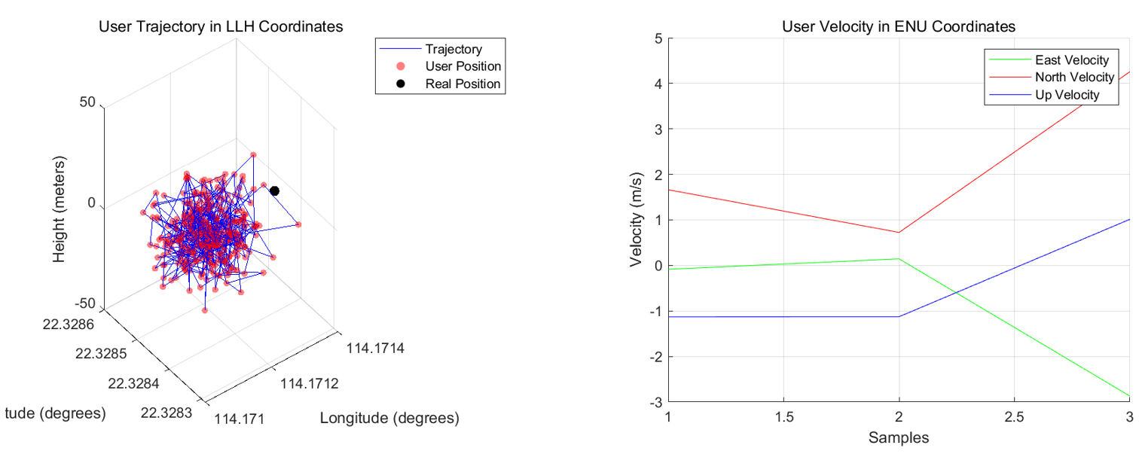

Fig. 3. The position and velocity of Open-Sky dataset

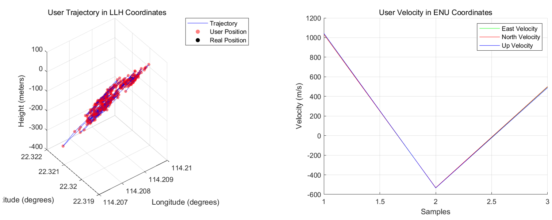

Fig. 4. The position and velocity of Urban dataset

Effects of Multipath on Weighted Least Squares (WLS) Solutions

1. Increased Measurement Errors

In a multipath environment, the received signals often include not only signals coming directly from the satellites but also reflected signals from surrounding objects. These reflected signals can have time delays, leading to errors in pseudorange measurements. This error affects the input data for WLS, resulting in inaccurate estimates.

1. Impact on Weight Selection

The WLS method minimizes weighted residuals by assigning different weights to observations. If the multipath effect significantly impacts certain measurements, it can increase the variance of those data, thus affecting the distribution of weights. If the weighting strategy is unreasonable, some observations heavily impacted by multipath may still be assigned high weights, further reducing positioning accuracy.

1. Poor Model Fitting

WLS relies on a correct model to fit the observed data. If the observed data deviate due to multipath effects, the model's fit will decrease, leading to a deterioration in the accuracy of the final solution.

1. Impact on Estimated Results

In WLS, the goal is to determine the position by minimizing the weighted residuals between the observed values and the expected values. If the input pseudoadDistances are affected by multipath, this leads to coordinate estimates that deviate from the true values, especially in open environments or areas severely obstructed by buildings and terrain.

Some Methods to Mitigate Multipath Effects

1. Signal Processing Techniques

Employ more advanced signal processing techniques, such as multi-channel receivers or differential GNSS technology, to improve positioning accuracy and mitigate multipath effects.

1. Use Appropriate Weights

In WLS, adjust the weights dynamically based on the quality of measurements to reduce the weight assigned to observations heavily affected by multipath.

1. Improve Models

Develop predictive models that account for multipath effects, incorporating the errors induced by multipath into the models to enhance the robustness of WLS solutions.

1. Environmental Adaptation

Follow suitable environmental choices for GNSS reception, such as selecting open areas to reduce the impact of multipath or using multipath-resistant antenna designs when necessary.

### **Task 5 – Kalman Filter-Based Positioning**

Develop an Extended Kalman Filter (EKF) using pseudorange and Doppler measurements to estimate user position and velocity.